Sweet Crumb Bakery

Introduction
My name is Nikodem Nowak and I have designed a fictional cake company based in newton-le-willows named Sweet Crumb Bakery. It is a five-page website which was built using HTML5 and CSS3 as per assignment brief.
The five pages are: Home, Our Cakes, Customise, Accessories, and Contact. Each page uses consistent navigation, semantic HTML5 elements, and a shared external stylesheet for a clean look across the site. The layout is responsive and adjusts for tablets and mobile phones using a CSS media query.

Sitemap
The diagram below shows how the five pages are linked together. Every page is accessible from the main navigation bar, which appears at the top of every page.
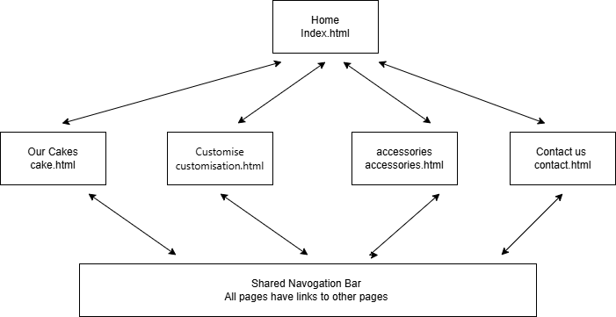

Wireframes
Before coding, I used https://app.diagrams.net to sketch wireframes for each page to plan the layout of headers, navigation, content areas, and footers.
Home Page
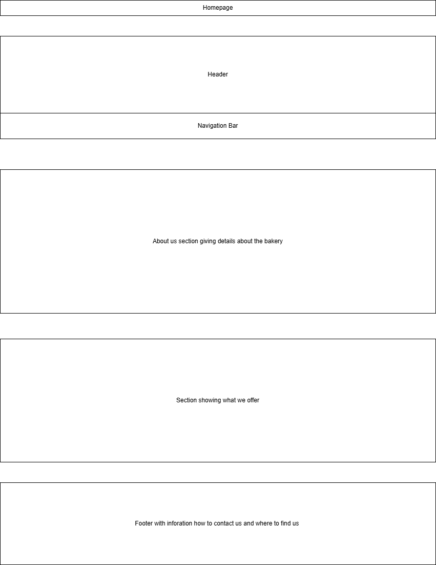

Our Cakes Page
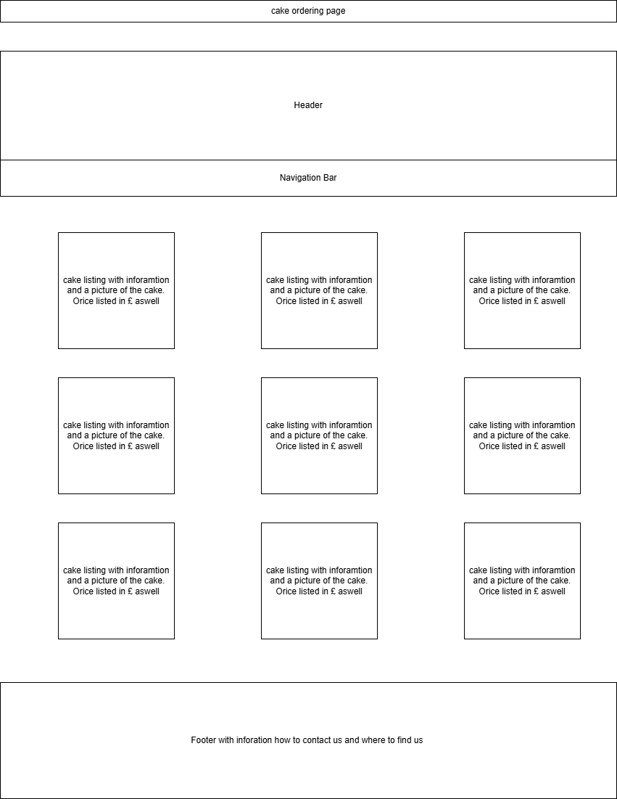
Customise Page
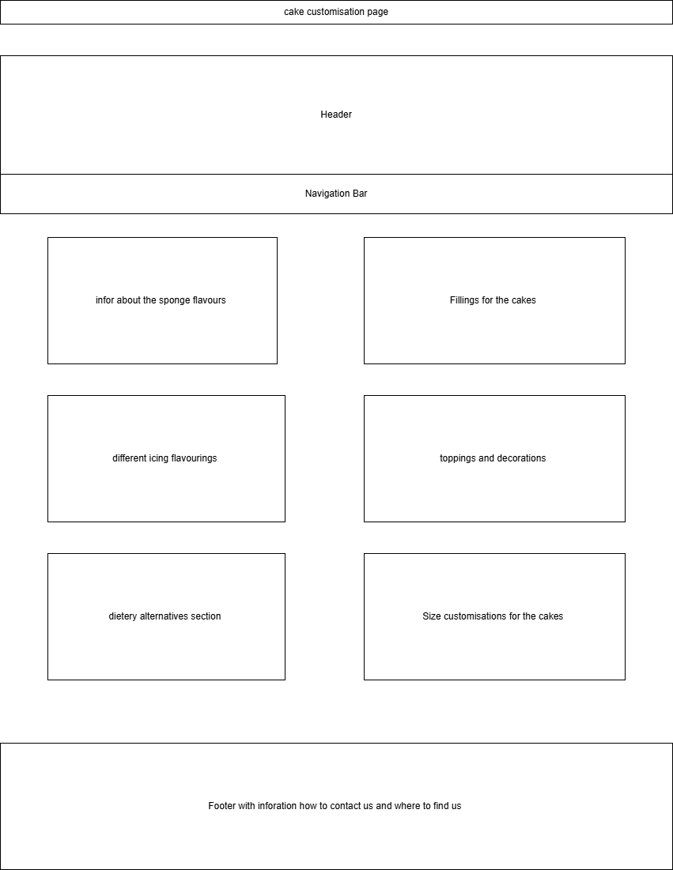
Accessories Page
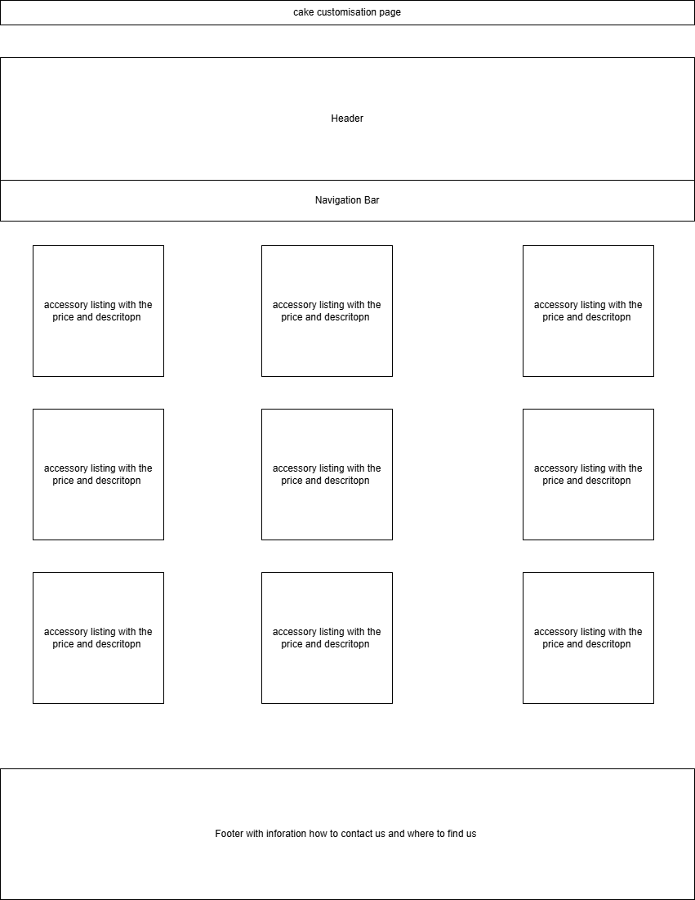
Contact Page
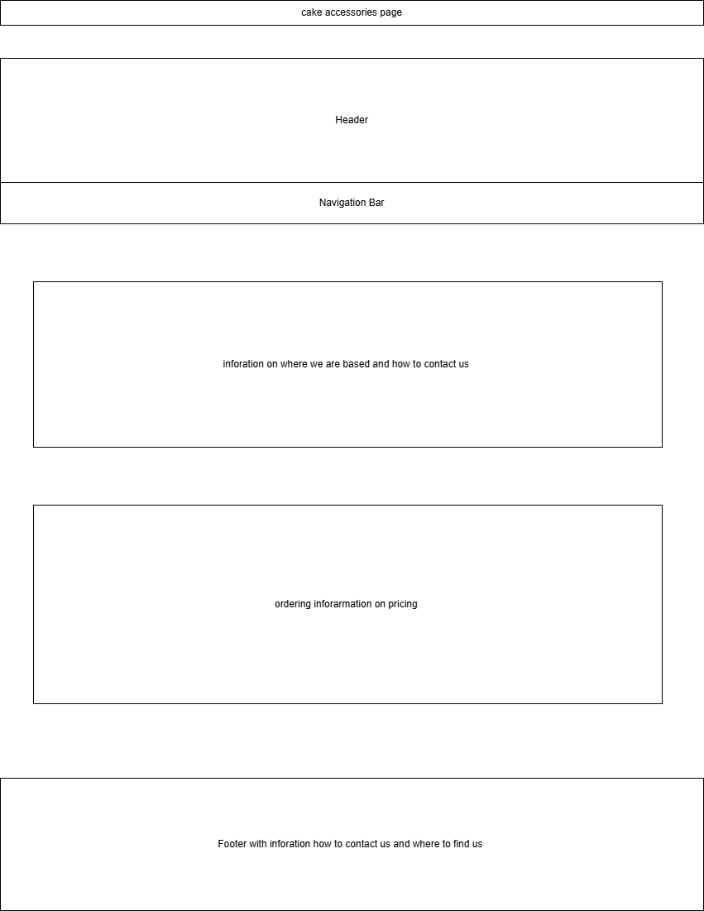

Colour Scheme
The website uses a warm, bakery-inspired palette consisting of five main colours, defined as CSS variables at the top of the stylesheet for easy maintenance.
Name | Hex Code |  | Used For
Cream | #fdf6ec |  | Page background
Red | #ff0000 |  | Header, primary accents
Dark Pink | #b76e79 |  | Hover states, headings
Brown | #5b3a29 |  | Body text, nav bar, footer
Gold | #c9a961 |  | Accent borders, button hovers
HTML Validation Results
All five HTML pages were validated using the official W3C Markup Validator (https://validator.w3.org). No errors or warnings were reported for any page.
Home page (index.html)
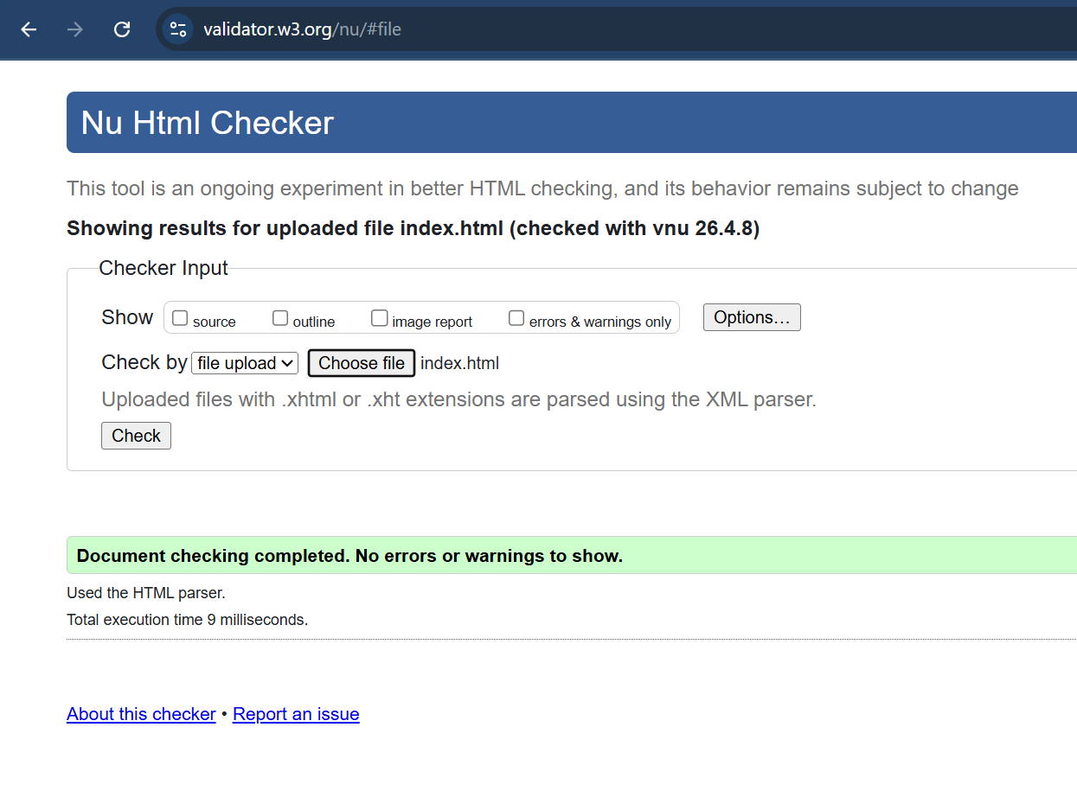
Our Cakes (cakes.html)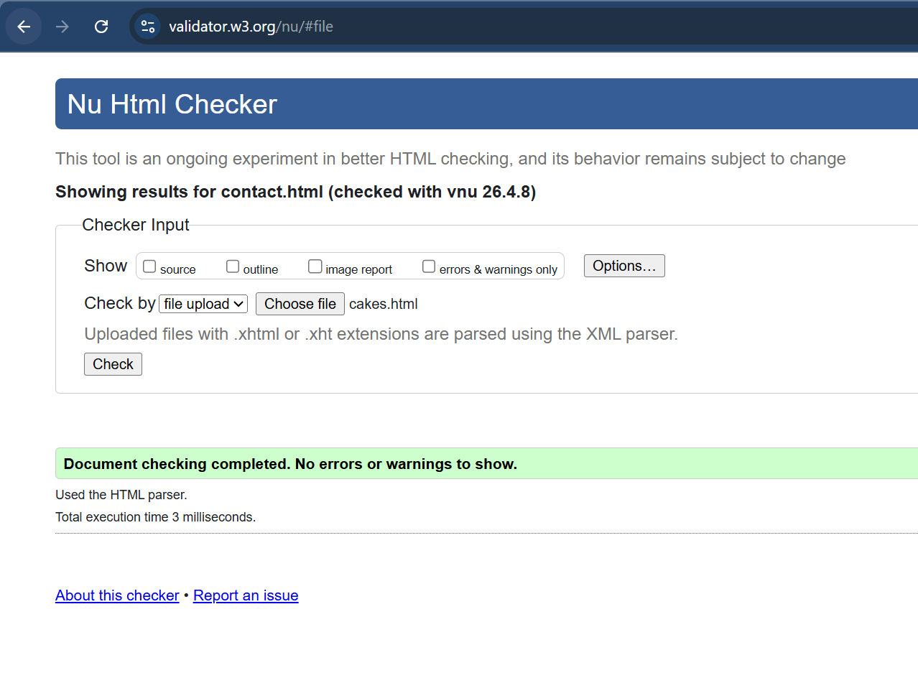

Customise (customisation.html)
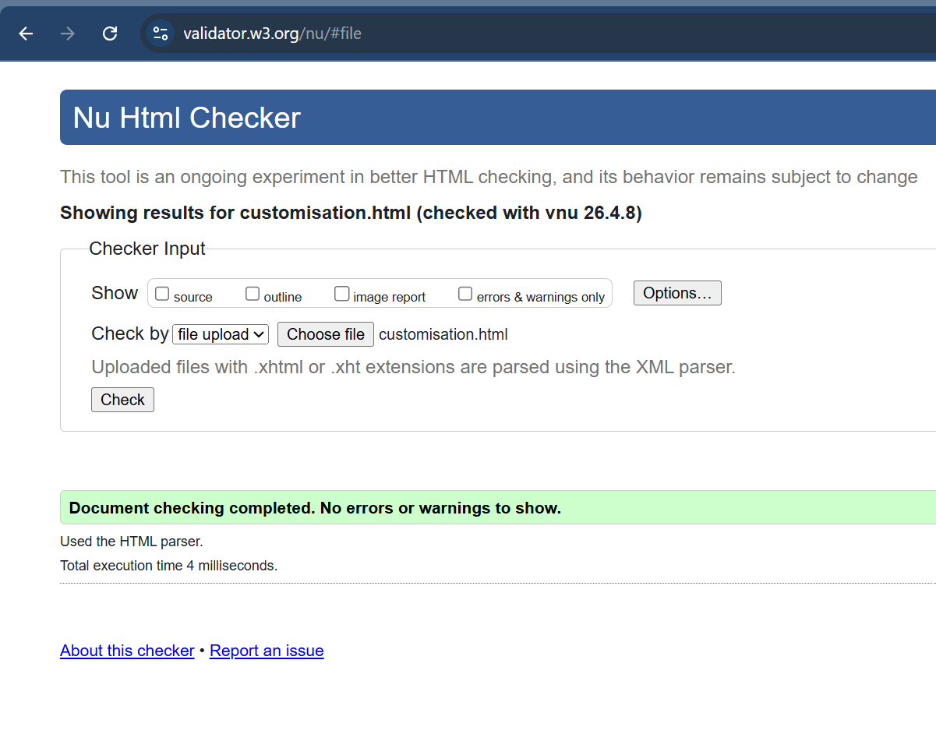
Accessories (accessories.html)
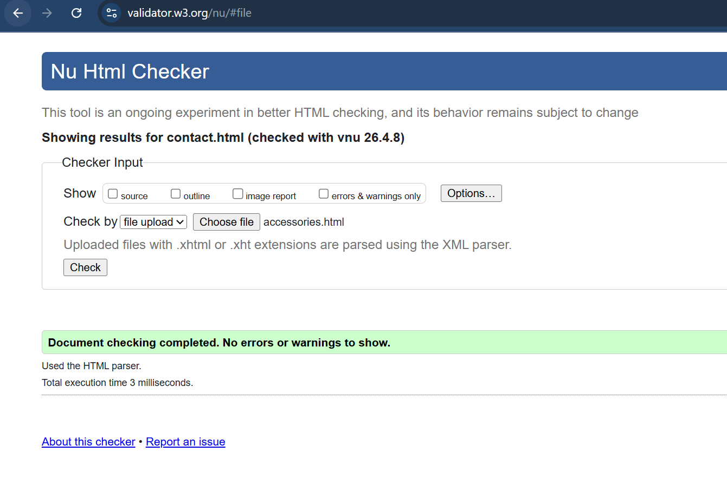
Contact (contact.html)
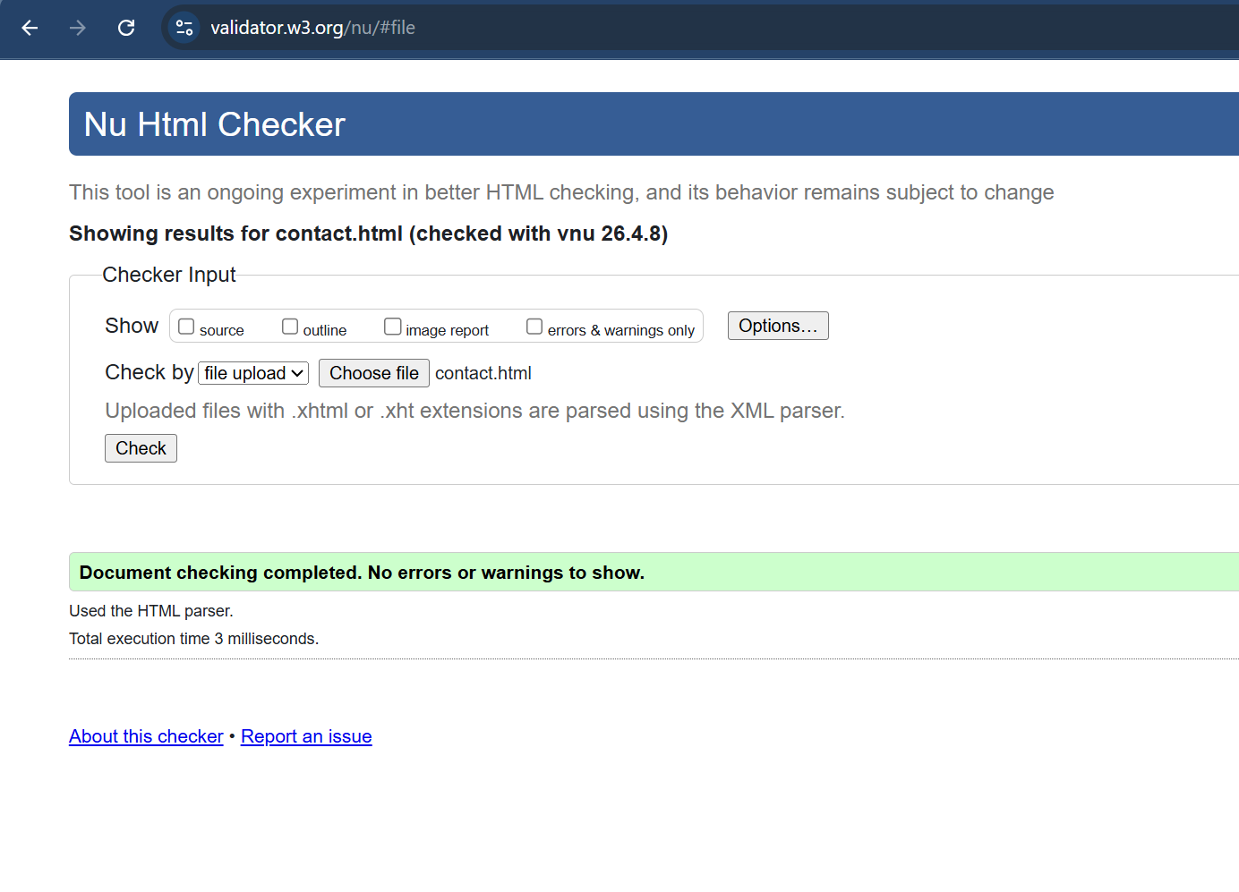
CSS Validation Results
The stylesheet style.css was validated using the W3C CSS Validator (https://jigsaw.w3.org/css-validator/). No errors were found.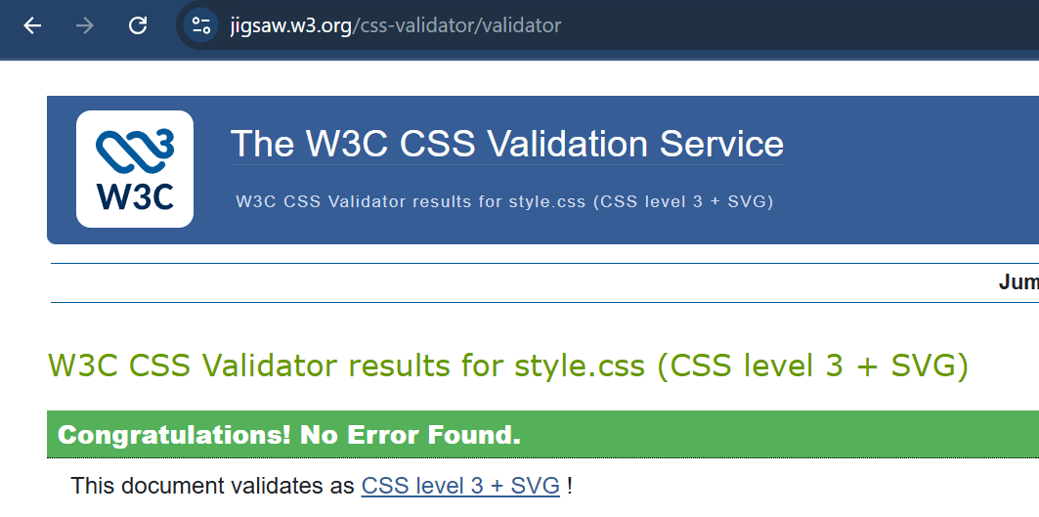

Cross-Browser Testing
The website was tested in the three major desktop browsers — Google Chrome, Firefox, and Microsoft Edge as well as in mobile viewport mode in firefox. All pages rendered consistently and correctly.
Google Chrome 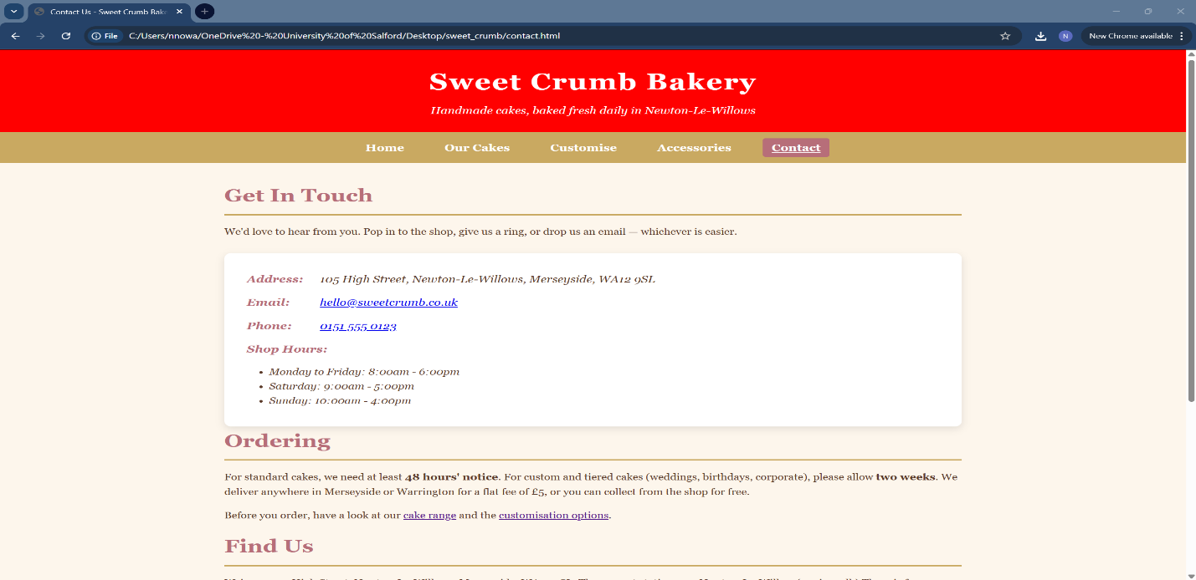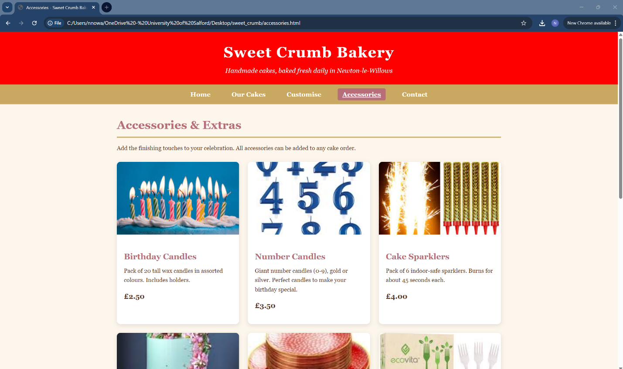
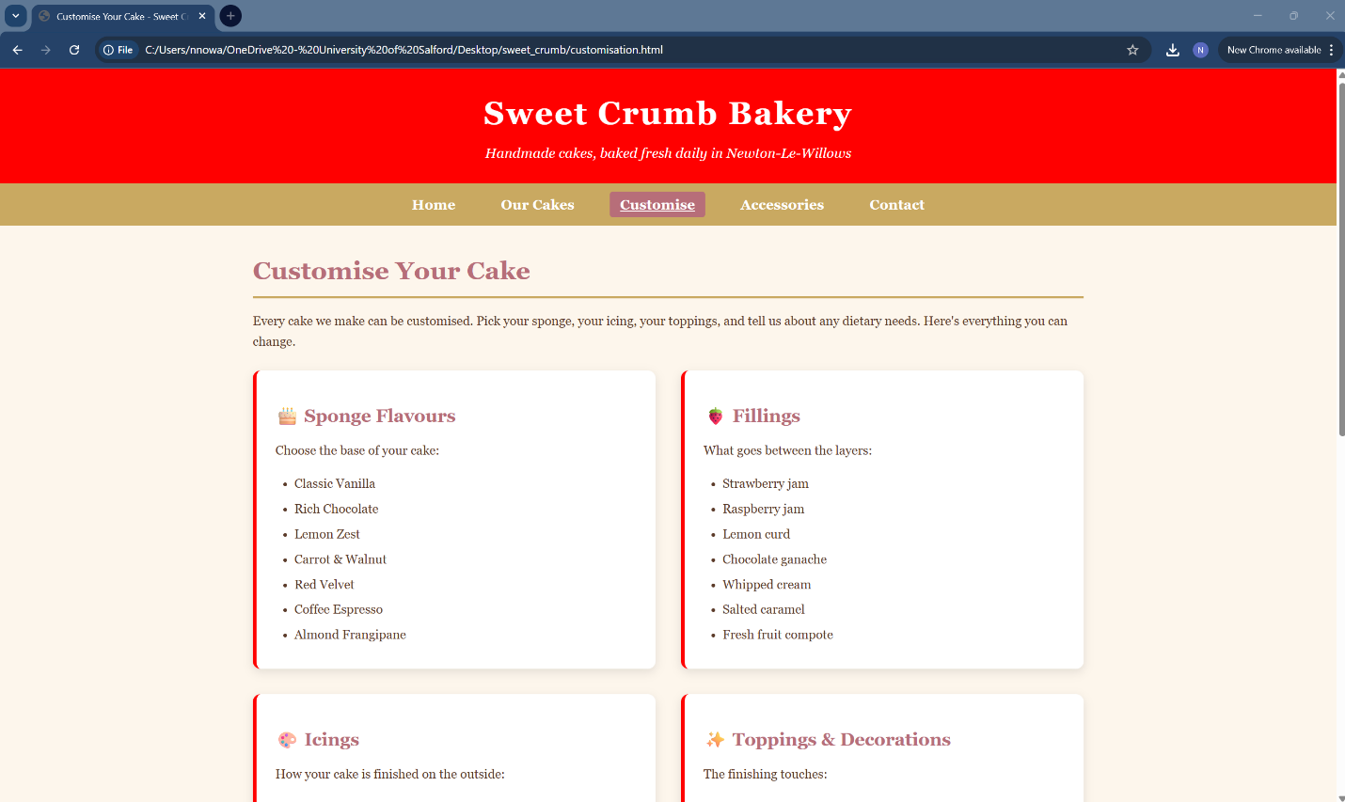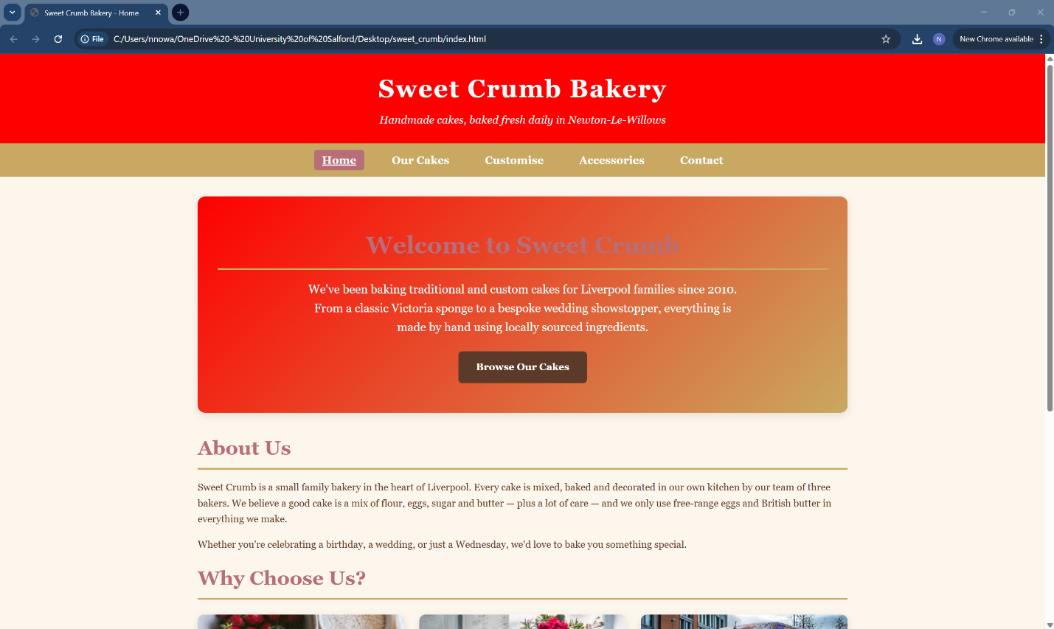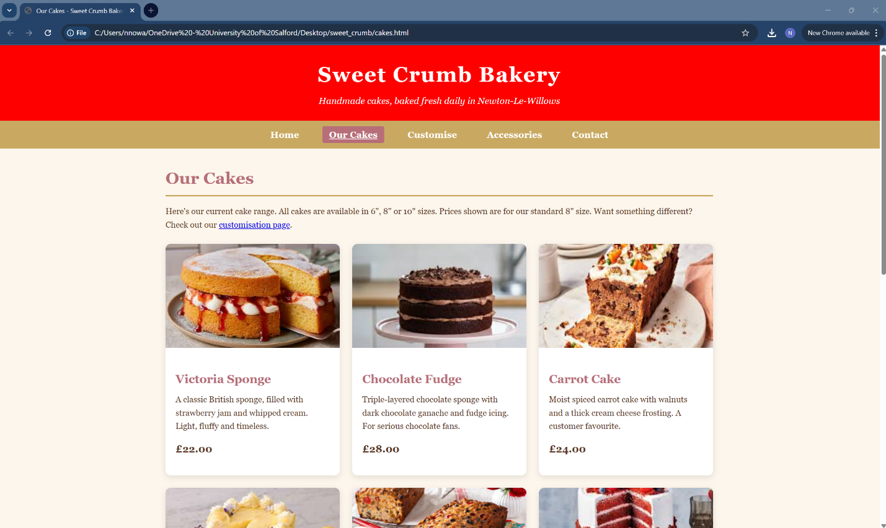
Firefox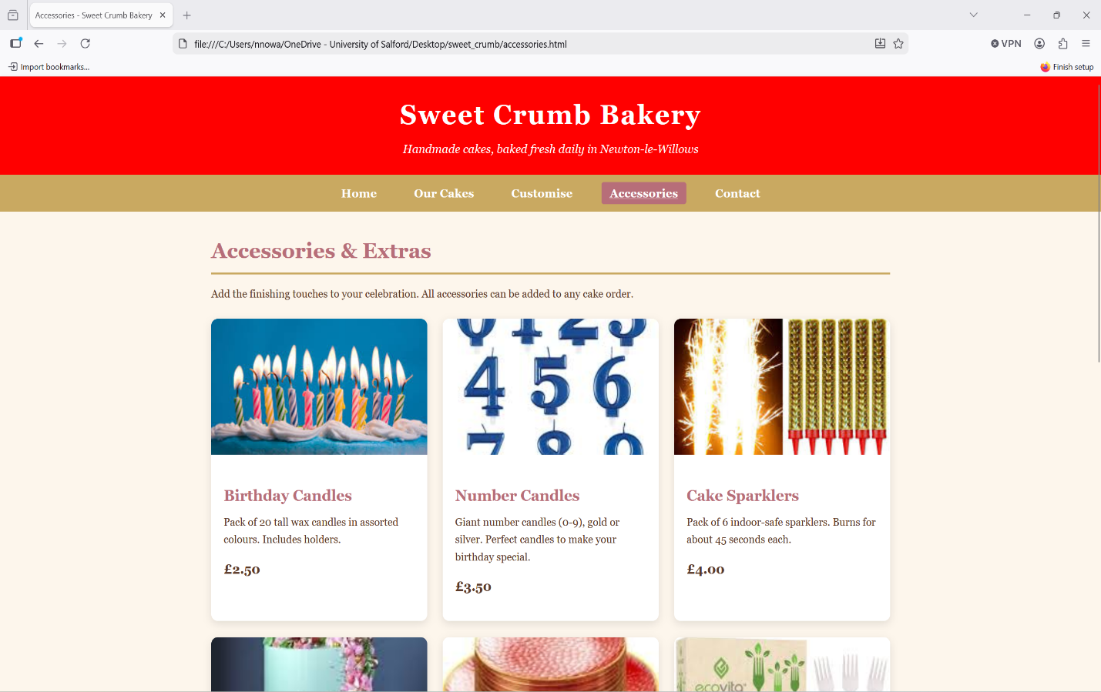
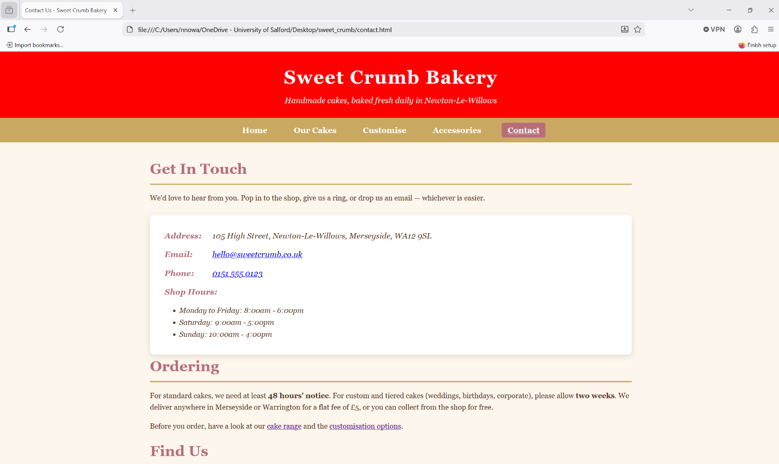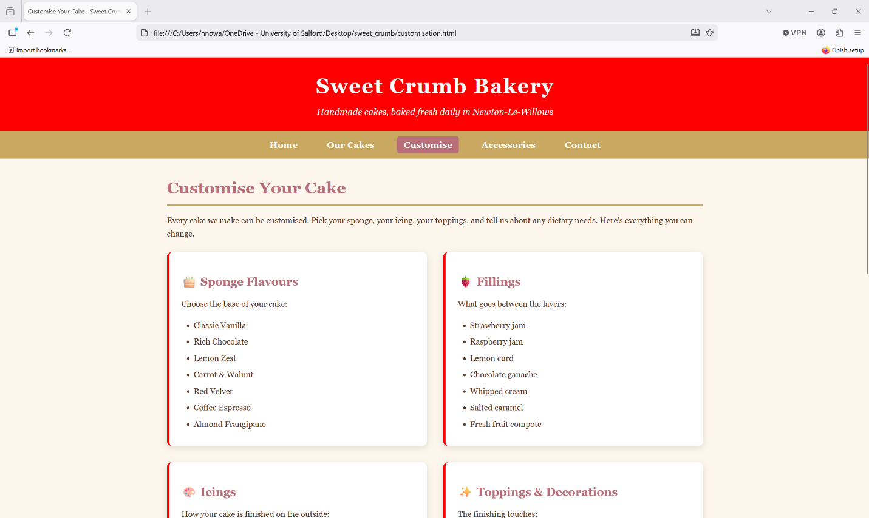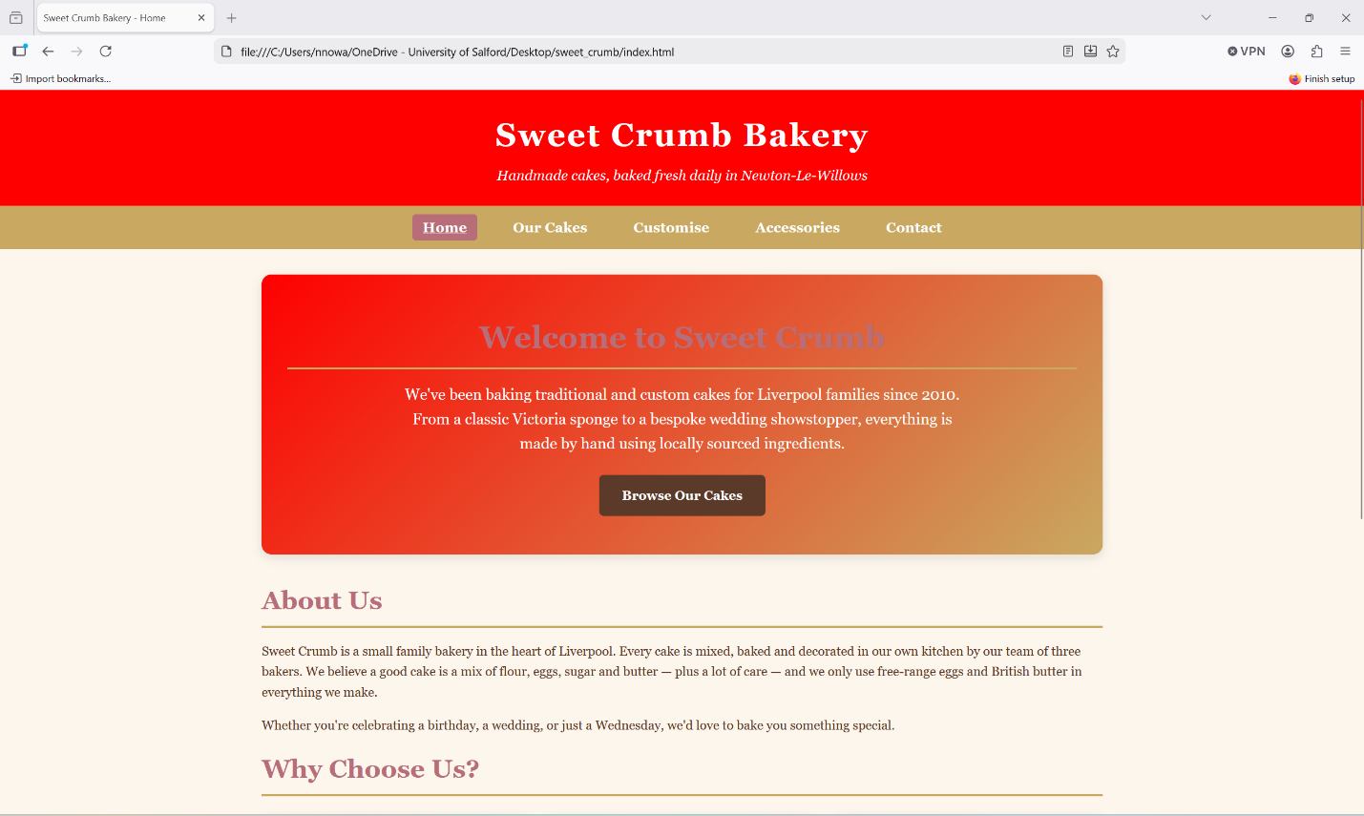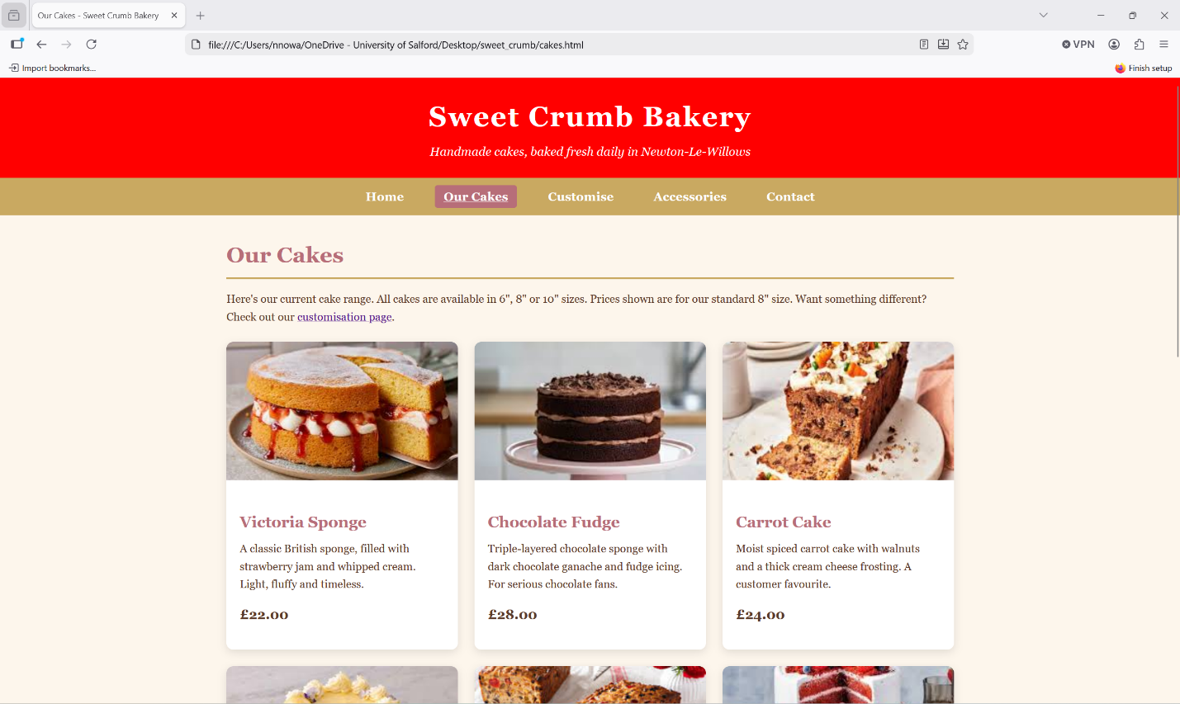

Microsoft Edge
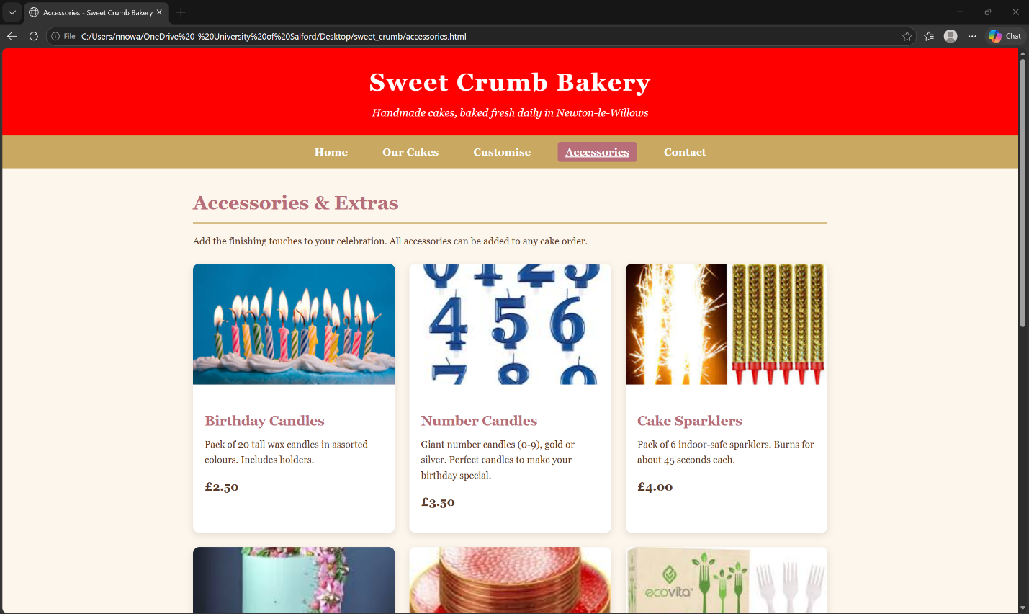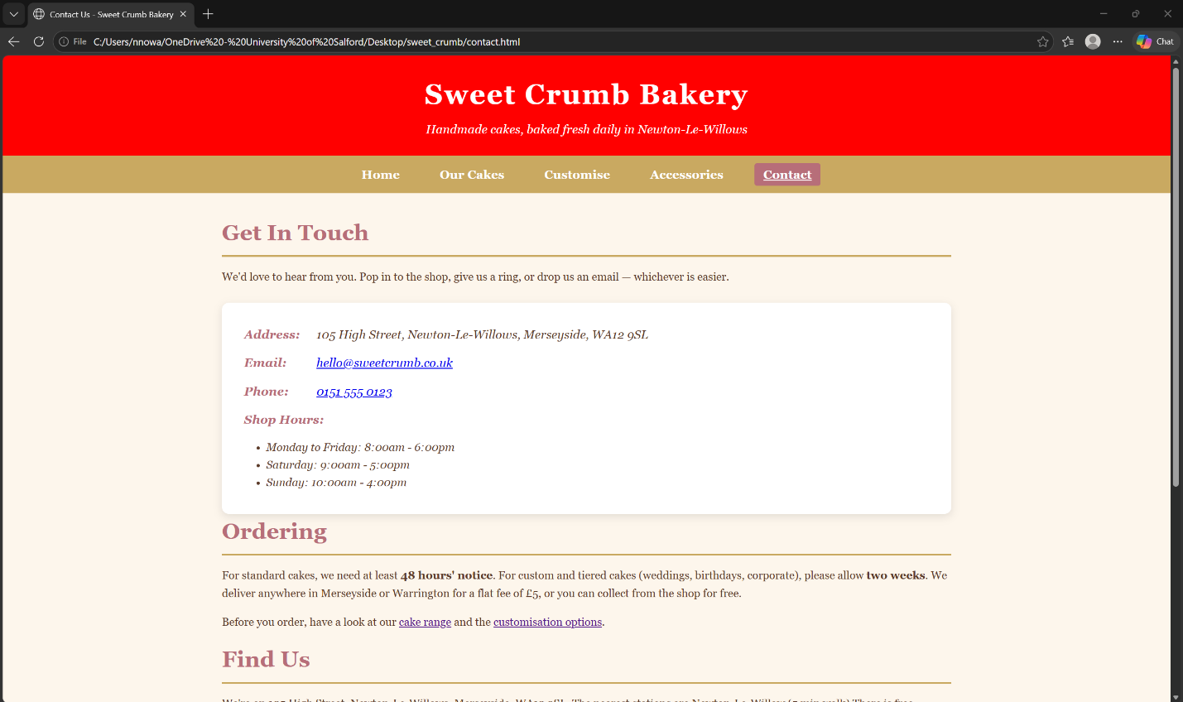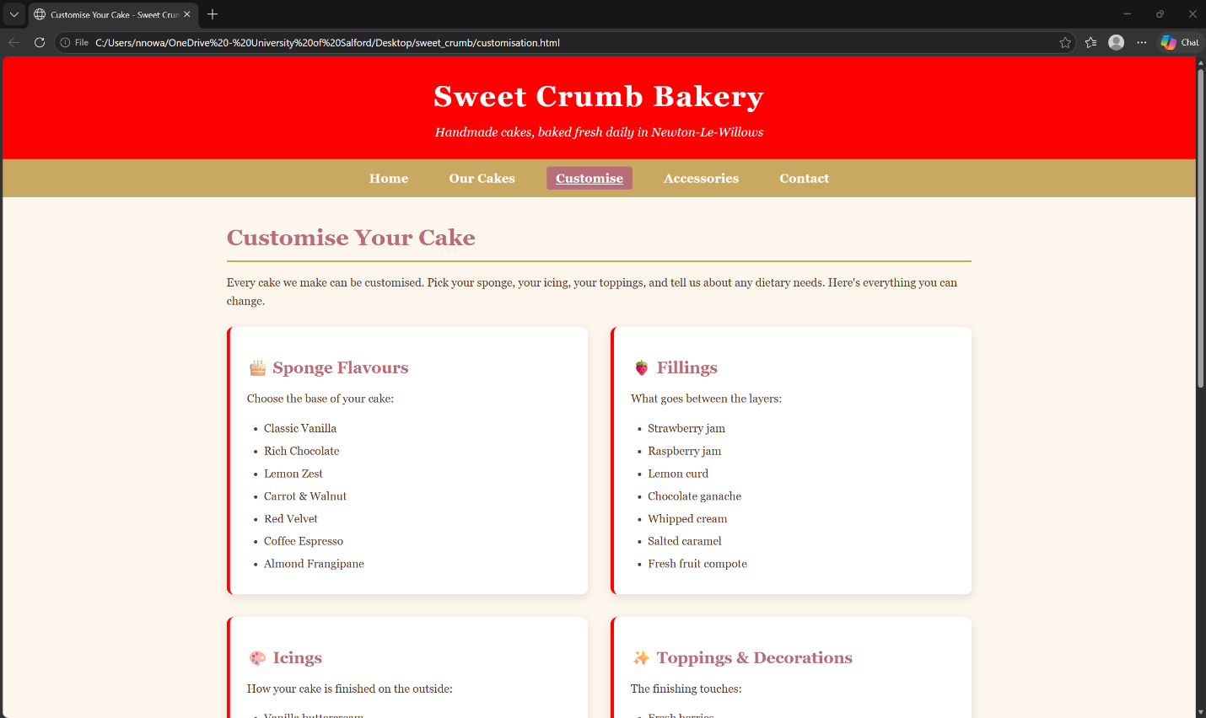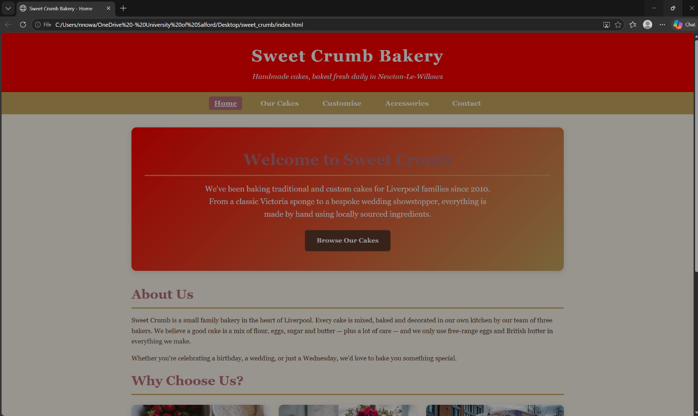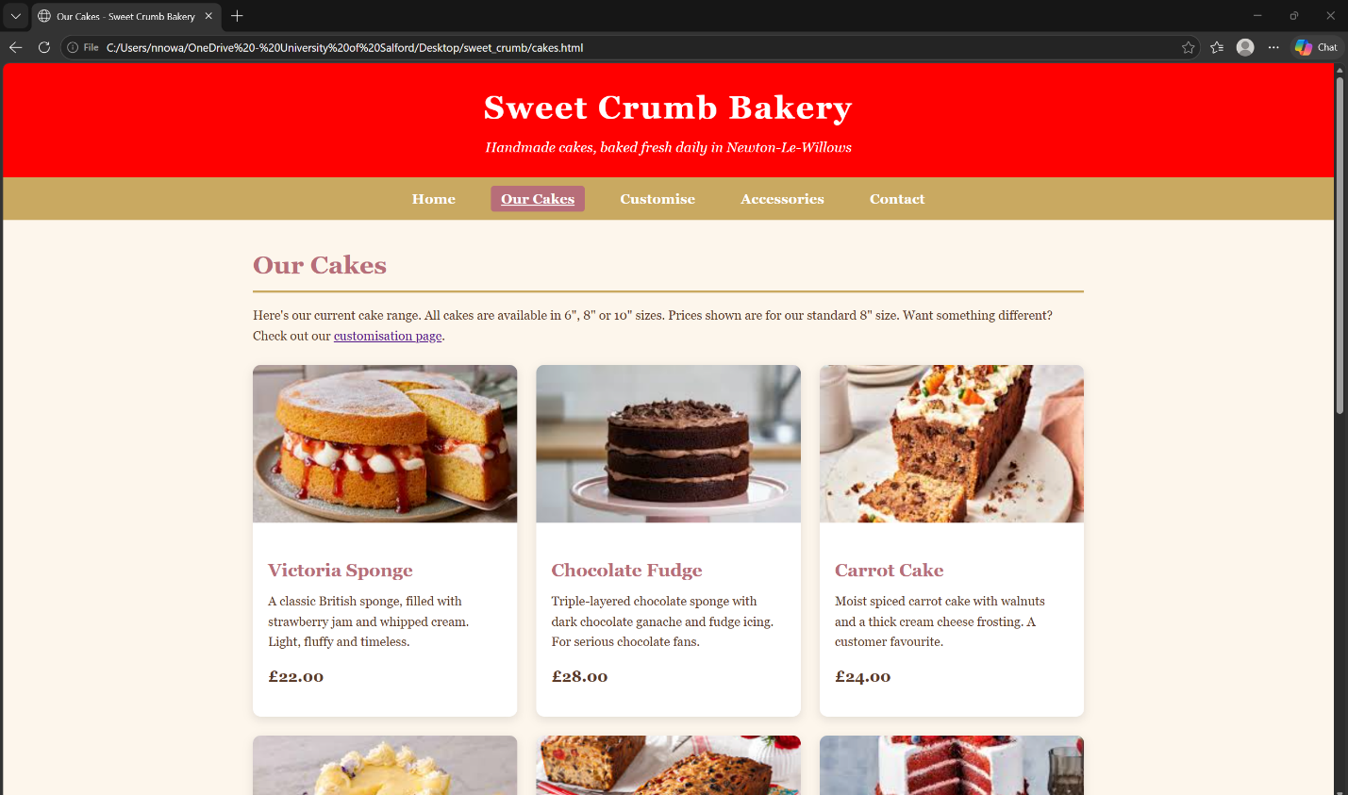

Mobile View (Firefox by clicking control, shift + M)
